|  |  |
| --- | --- |
| **ID** | Recover_Username_Err_01 |
| **Server Name** | http://localhost:7777/portalserver/banamex-cards-es/recover-username/ |
| **UI Error Message** | Verifica que la información sea correcta. |
| **BackBase Error Response Body** | {   "errorCode": "401",  "errorType": "INVALID_CARD",  "details" : "Invalid credit card details"  } |
| **APIm Error Response Body** | {  "code": "invalidCard",  "details": "The Card details entered are invalid",  "type": "ERROR"  } |
| **Root Cause** | Invalid credit card details |
| **Additional Information (if any)** | The user needs to check all the information entered is correct. |
| **Screenshot** | Below |
|  |  |

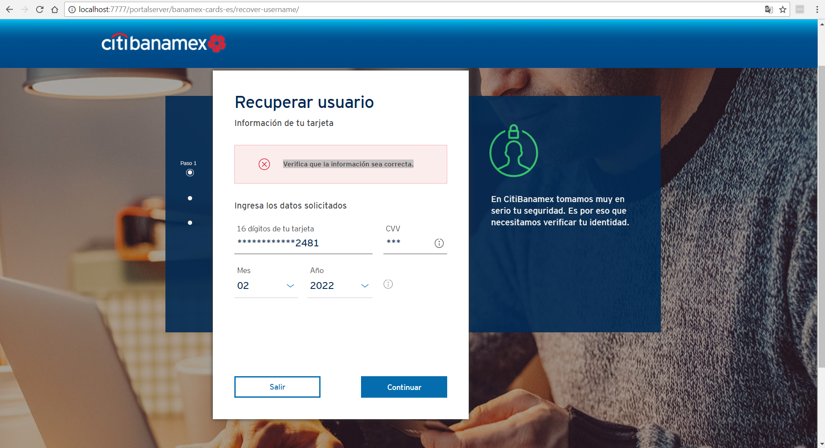

|  |  |
| --- | --- |
| **ID** | Recover_Username_Err_02 |
| **Server Name** | http://localhost:7777/portalserver/banamex-cards-es/recover-username/ |
| **UI Error Message** | Verifica tu celular. |
| **BackBase Error Response Body** | {"status":"INCORRECT_VALIDATION_PHONE"} |
| **APIm Error Response Body** | NA |
| **Root Cause** | Incorrect phone number |
| **Additional Information (if any)** | The users enters incorrect phone number |
| **Screenshot** | Below |
|  |  |

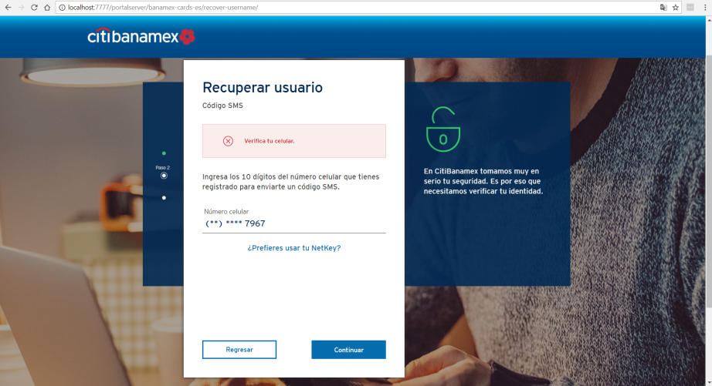

|  |  |
| --- | --- |
| **ID** | Recover_Username_Err_03 |
| **Server Name** | http://localhost:7777/portalserver/banamex-cards-es/recover-username/ |
| **UI Error Message** | Inténtalo de nuevo. |
| **BackBase Error Response Body** | {  "errorCode": "401",  "errorType": "OTP_INVALID_CODE"  } |
| **APIm Error Response Body** |  |
| **Root Cause** | Invalid OTP code |
| **Additional Information (if any)** |  |
| **Screenshot** | Below |
|  |  |

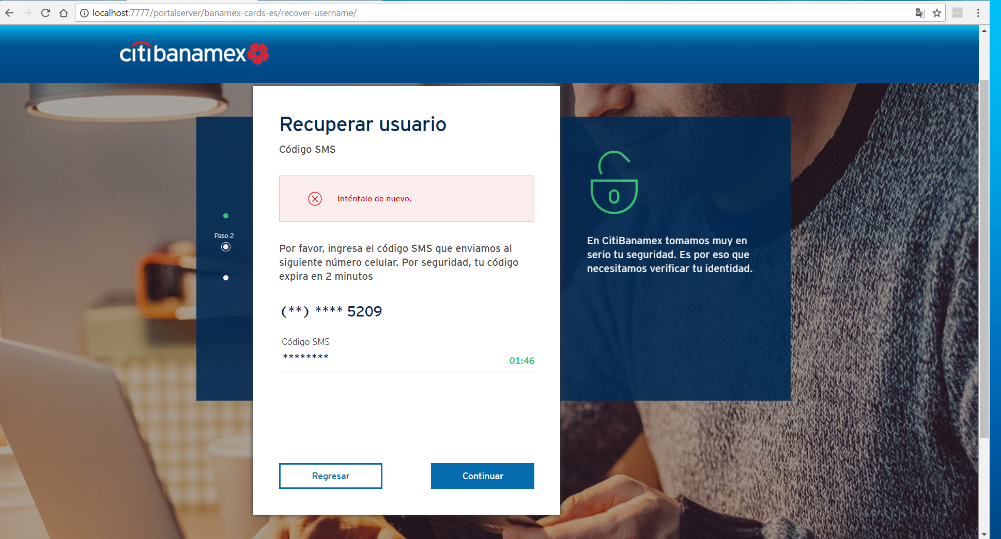

|  |  |
| --- | --- |
| **ID** | Recover_Username_04 |
| **Server Name** | http://localhost:7777/portalserver/banamex-cards-es/recover-username/ |
| **UI Error Message** | Verifica que tu usuario y/o contraseña sean correctas |
| **BackBase Error Response Body** | {  "code" : "20",  "status" : 403,  "type" : "invalid",  "message" : null  } |
| **APIm Error Response Body** |  |
| **Root Cause** | Password is invalid |
| **Additional Information (if any)** |  |
| **Screenshot** | Below |

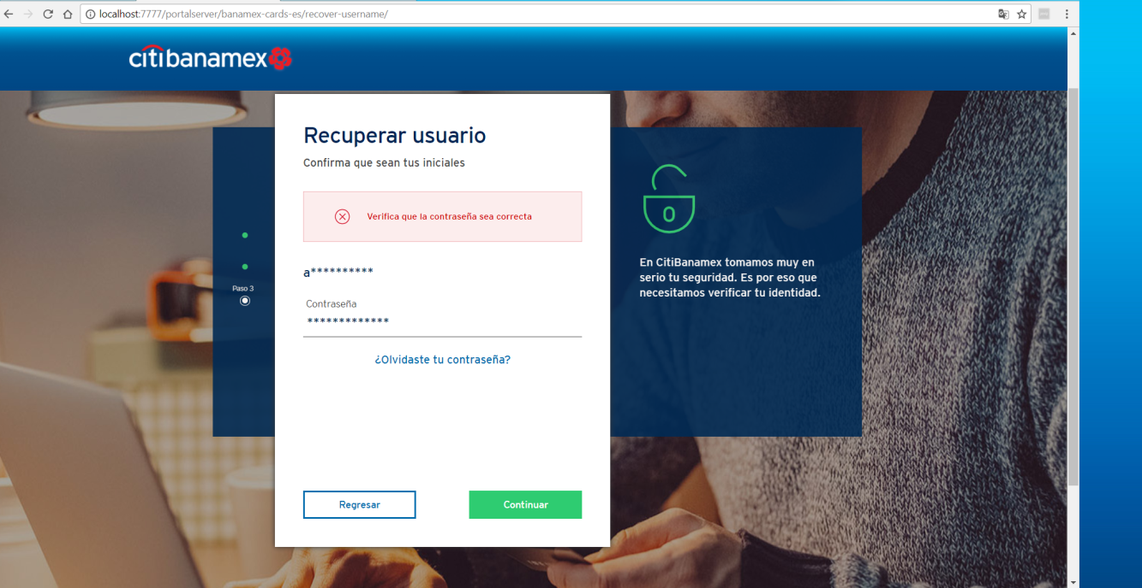

|  |  |
| --- | --- |
| **ID** | Recover_Username_Err_05 |
| **Server Name** | http://localhost:7777/portalserver/banamex-cards-es/recover-username/ |
| **UI Error Message** | Acceso bloqueado - Por favor espera 24 horas y vuelve a intentarlo. |
| **BackBase Error Response Body** | {"errorCode":"401","errorType":"ACCESS_BLOCKED"} |
| **APIm Error Response Body** | {"type":"error","code":"userAccountLocked","details":" 200011-account locked"} |
| **Root Cause** | Five consecutive invalid otp attempt leads access blocked in pre login |
| **Additional Information (if any)** |  |
| **Screenshot** | Below |

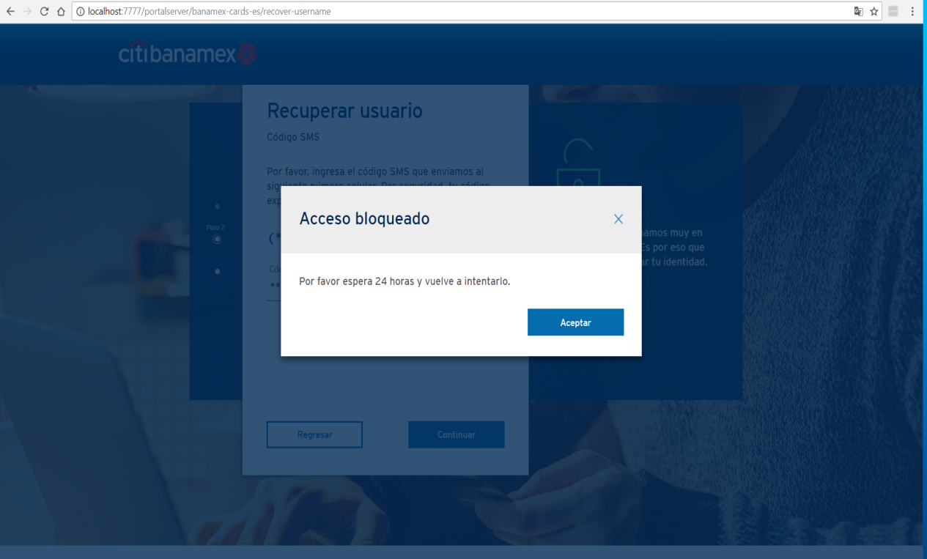

|  |  |
| --- | --- |
| **ID** | Recover_Username_Err_06 |
| **Server Name** | http://localhost:7777/portalserver/banamex-cards-es/recover-username/ |
| **UI Error Message** | **Registro inválido**  Por motivos de seguridad no se ha podido completar tu operación. Por favor, comunícate al Centro de Atención Telefónica:  *De la Ciudad de México: 1226 2639 / 2262 6301 *Del interior sin costo: 01 800 021 2345. |
| **BackBase Error Response Body** | {  "code":"6906",  "details":"Invalid Card Details",  "type":"CARD_BLOCK"  } |
| **APIm Error Response Body** | {      "validCard": true,      "ccsCardRegistry": true,      "cardTypeIndicator": "P",      "customerRelationshipID": "0000000000082480155",      "electronicAccess": false,      "cardBlockResponse": {          "tempBlock": false,          "cardBlockStatusCode": true,          "accountBlockStatusCode1": null,          "accountBlockStatusCode2": null      },      "cardErrorMessage": "",      "cardErrorCode": "0"  } |
| **Root Cause** | User has enter a card blocked |
| **Additional Information (if any)** |  |
| **Screenshot** | Below |

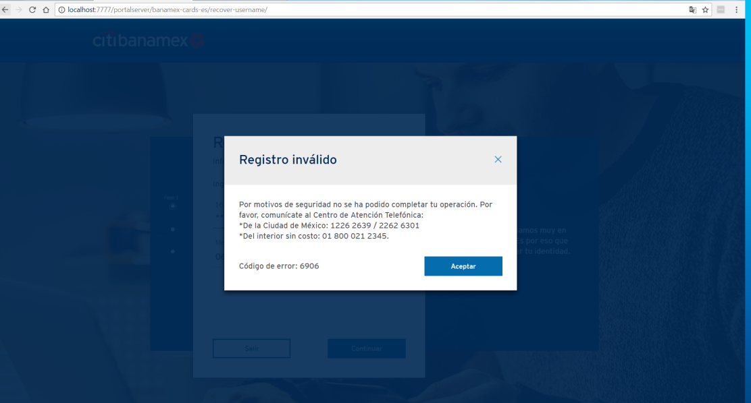

|  |  |
| --- | --- |
| **ID** | Recover_Username_Err_07 |
| **Server Name** | http://localhost:7777/portalserver/banamex-cards-es/recover-username/ |
| **UI Error Message** | En este momento no podemos completar tu solicitud. Inténtalo más tarde. |
| **BackBase Error Response Body** | {  "errorCode": "500",     "errorType": "TECHNICAL_DIFFICULTY",      "details" : "Technical Difficulty"  } |
| **APIm Error Response Body** | {  "type": "error",  "code": "serverUnavailable",  "details": "The request failed due to an internal error/server unavailability"  } |
| **Root Cause** | APIM is down. |
| **Additional Information (if any)** |  |
| **Screenshot** | Below |
|  |  |

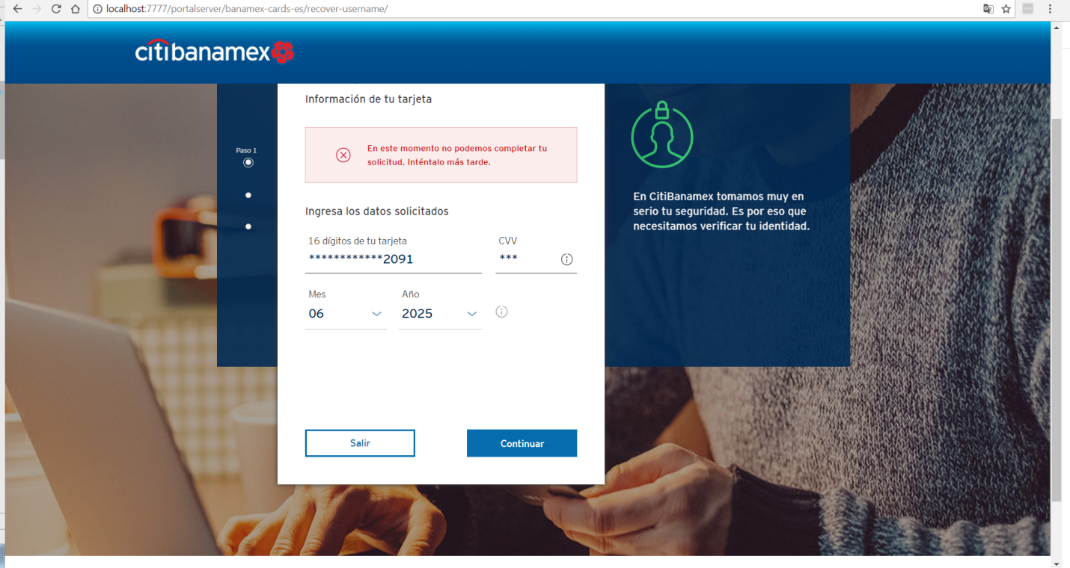

|  |  |
| --- | --- |
| **ID** | Recover_Username_Err_08 |
| **Server Name** | http://localhost:7777/portalserver/banamex-cards-es/recover-username/ |
| **UI Error Message** | Acceso inválido |
| **BackBase Error Response Body** | {   "errorCode": "401",  "errorType": "SOFT_BLOCKED",  } |
| **APIm Error Response Body** | {"type":"error","code":"userAccountLocked","details":" 15-account locked"} |
| **Root Cause** | If the user enters invalid details 5 consecutive times. |
| **Additional Information (if any)** |  |
| **Screenshot** | Below |
|  |  |

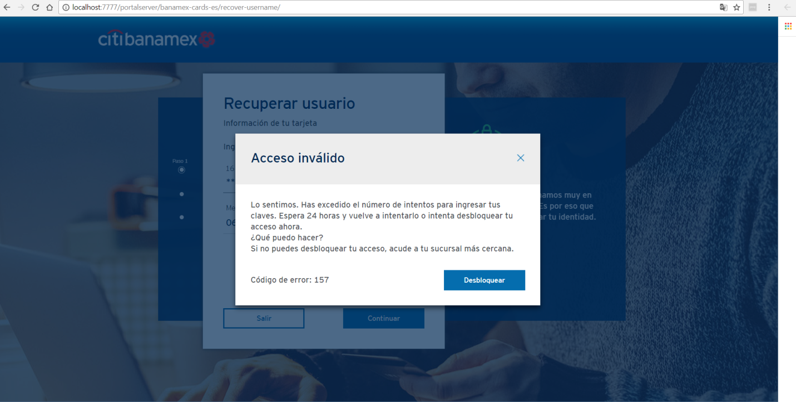

|  |  |
| --- | --- |
| **ID** | Recover_Username_Err_09 |
| **Server Name** | http://localhost:7777/portalserver/banamex-cards-es/recover-username/ |
| **UI Error Message** | Acceso inválido |
| **BackBase Error Response Body** | {   "errorCode": "401",  "errorType": "HARD_BLOCKED",  } |
| **APIm Error Response Body** | {"type":"error","code":"userAccountLocked","details":" 180-account locked"} |
| **Root Cause** | If the user enters invalid details 20 or more times, he/she will be hard blocked |
| **Additional Information (if any)** |  |
| **Screenshot** | Below |
|  |  |

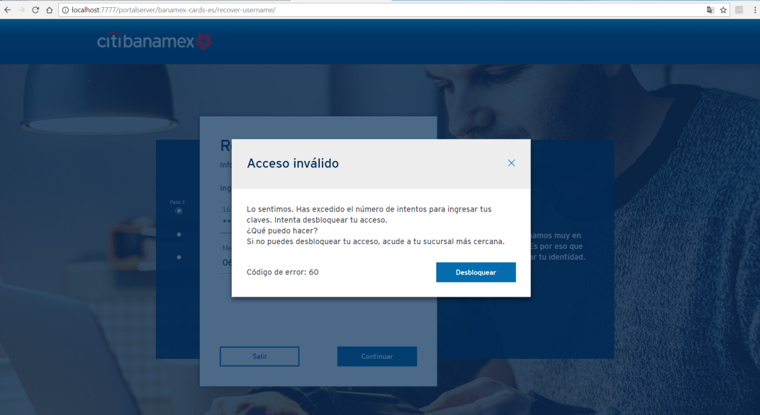

|  |  |
| --- | --- |
| **ID** | Recover_Username_Err_10 |
| **Server Name** | http://localhost:7777/portalserver/banamex-cards-es/recover-username/ |
| **UI Error Message** | Registro inválido |
| **BackBase Error Response Body** | {   "errorCode": "401",  "errorType": "CARD_STOLEN",  } |
| **APIm Error Response Body** | {      "validCard": true,      "ccsCardRegistry": true,      "cardTypeIndicator": "P",      "customerRelationshipID": "0000000000082480155",      "electronicAccess": false,      "cardBlockResponse": {          "tempBlock": false,          "cardBlockStatusCode": S,          "accountBlockStatusCode1": null,          "accountBlockStatusCode2": null      },      "cardErrorMessage": "",      "cardErrorCode": "0"  } |
| **Root Cause** | If the card was stolen and tried to recover username |
| **Additional Information (if any)** |  |
| **Screenshot** | Below |
|  |  |

